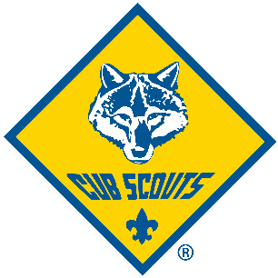

The Most
Awesome and Super
CUB SCOUT
SUMMER PASSPORT

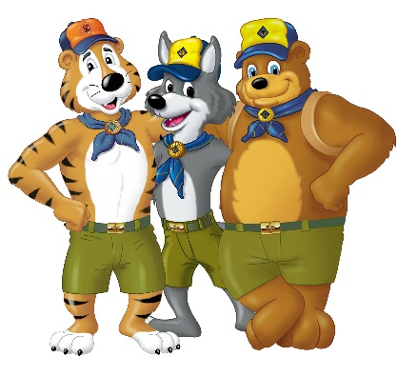
[Add your Pack contact information here]

Welcome to a Great Summer of Adventure with our Cub Scout Pack!
Whether a current Cub Scout, thinking of joining Cub Scouts, or a friend of a Cub Scout, we look forward to having your child join us for the adventures ahead. Every child will have the opportunity to grow, learn, and have fun while doing Cub Scout activities this summer.
Our pack is a family Pack with both boys and girls from Kindergarten through Fifth Grade.
THE MOST AWESOME AND SUPER CUB SCOUT SUMMER PASSPORT is designed for . . . you guessed it . . . an awesome summer of fun! With current social distancing and group size requirements, this SUMMER PASSPORT is designed to be completed with your family or virtually.
Within this passport you will find four different themes. Each theme was created to give your child a better understanding of themselves and the world around them. [ADDITIONAL IDEA: There is also the opportunity to help with the design for our Pack Summer Passport Patch.]
To earn the National Pack Summertime Award, all you need to do is complete 2 activities from each theme and 4 additional activities for a total of 12. [ADDITIONAL IDEA: If your Cub Scout completes 16 of the activities they will become a Super-Duper Award Holder and will go into a prize drawing for a fun prize and for those who Complete the entire passport we have a special “Extreme Summer Award” and prize drawing.]
To complete the tasks, please have your child tape, color, stick, draw, or stamp something from the activity in the box provided.
Once your child has completed the activities please take pictures of the pages and email them to us at .

To earn the Award and be eligible for prizes, the SUMMER PASSPORT must be turned in to the Pack by August 31, 2020.
YOUTH INFORMATION:
NAME: ____________________________________________________
AGE: _______________________________ GRADE: ________________
CUB SCOUT/FRIEND/SIBLING: __________________________________
PARENTS’ NAME:_____________________________________________
EMAIL ADDRESS: ____________________________________________

[SUMMER PASSPORT PATCH DESIGN
Design Our Pack Summer Passport 2020 Patch]

Exploring My World:
Plant a Flower, Vegetable or Herb and look after it | Visit an Art Museum
Visit a Beach or Lake | Take a Hike in a Local Park
Watch a Sunrise or Sunset with Family and Friends | Visit a State/National Monument or Park
Exploring Me:
Go Swimming | Go Fishing
Attend a Summer Pack Event (Virtual counts!) | Attend a Cub Scout Summer Camp or Virtual Pack Campout
Recruit a Friend to Join Cub Scouts | Learn a New Skill
Exploring My Family:
Camp in your Backyard or build a fort inside & sleep in it | Play a game outside with the Family
Help make and Share a Family Snack | Go on a bike ride with your Parent
Have a Family Picnic | Help a Family member with a project
Exploring My Community:
Learn about a Historical Place near you & visit it | Pick a nearby town and visit it
Using Sidewalk chalk to leave a message for your Neighbor | Write a Thank You card to a First Responder or someone in your Community
Painting rocks and place them in the Community, to cheer people up | Picking up Trash in a Park or Local Community

